**Website design document**

**Done by: Ahmad Obeid**



**Website Goal**

Hakuna Matata is publishing a website to our dear customers who love happiness boxes. The website aims to tell you about hakuna matata, show its products’ menu, and make the ordering process more efficient. The customers can get to know us better, easily buy their order from our restaurant’s website and get what they like from hakuna’s menu while they are at home.

**Scope**

The website will cover the food service field. Buying restaurant products is what I want from the website to provide. The main features on the website are to view the restaurant, order (i.e., meals), and other features that the customer consuming is in the website scope.

**Requirements**

There are many functional requirements that the website will allow the customers to do.

* **Sign up and log in to the website.**

The customer can sign up to the website through the button in the home page that will come to him/her since the website is opened. He/she will enter their email and password. The process for log in, but he/she needs to be signed up to the website if the customer does not have an account.

* **View items’ menu**

The customer can see the restaurant’s menu through the menu’s page. After the log in, he/she can click on the menu’s page and scroll down/up to see the provided items.

* **Order items**

If the customer chooses an item to buy after seeing the menu, he/she can click on that item and go to the cart page.

* **View, edit, and delete order.**

Since the customer has done the ordering and clicked on the checkout button in the menu page, he/she will go directly to the cart page where the customer can see the order and the price. Also, he/she can edit the order if want to change it, or the customer can delet e the order.

**Sitemap**

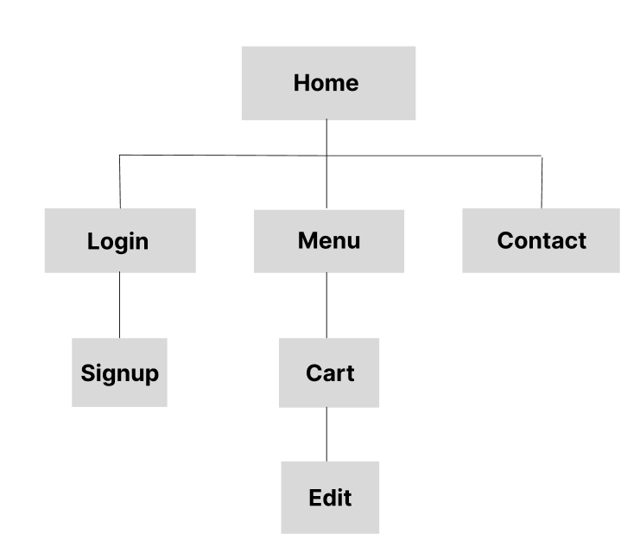

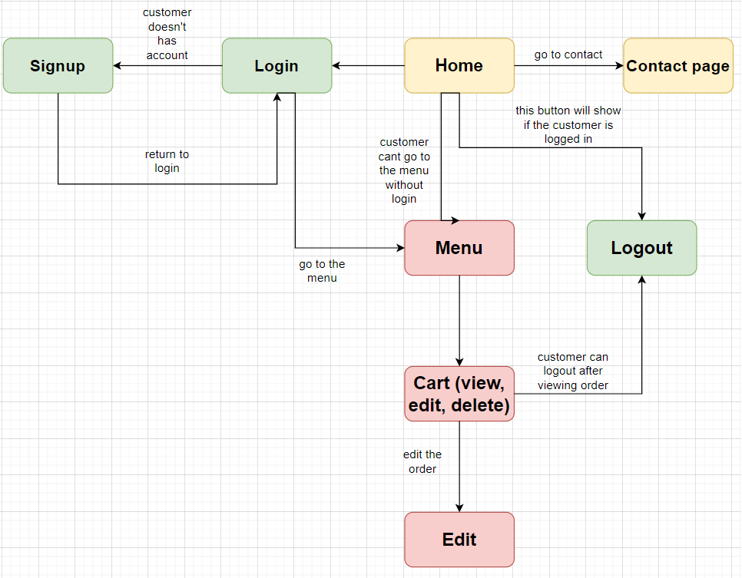

**Wireframes**

**For the mobile**

**Login page**

**Signup page**

**Home page**

**Contact page**

**Menu page**

**Cart page**

**Edit page**

**For PCs**

**Login page**

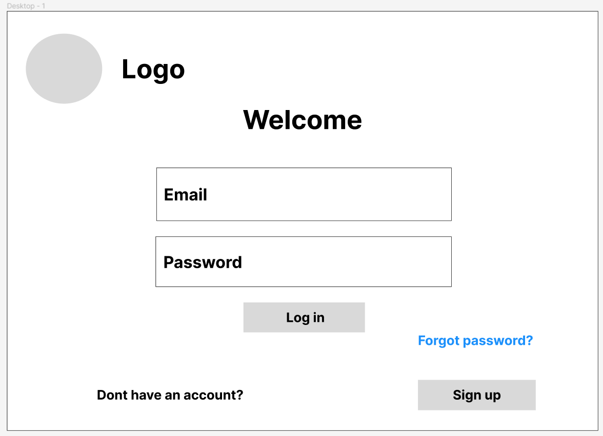

**Signup page**

**Home page**

**Contact page**

**Menu page**

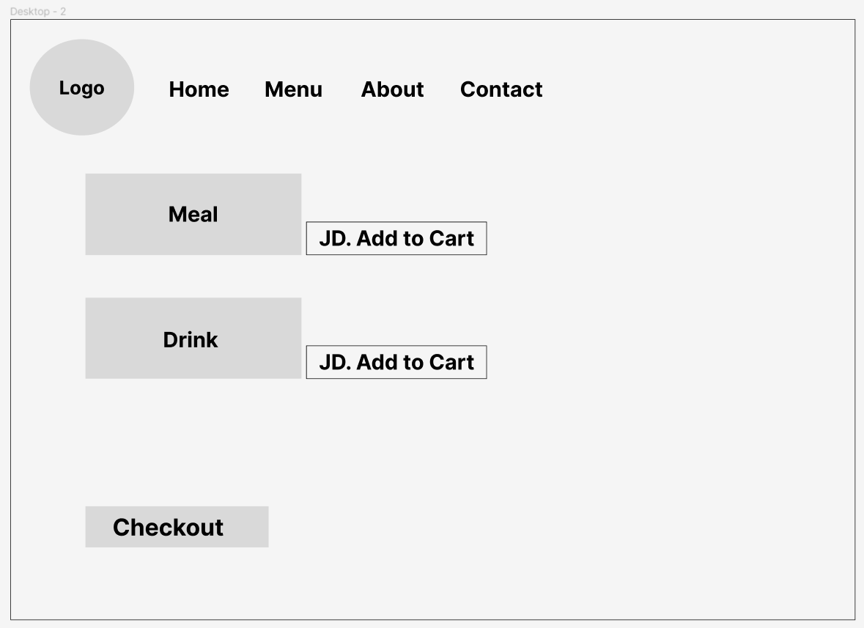

**Cart page**

**Edit page**

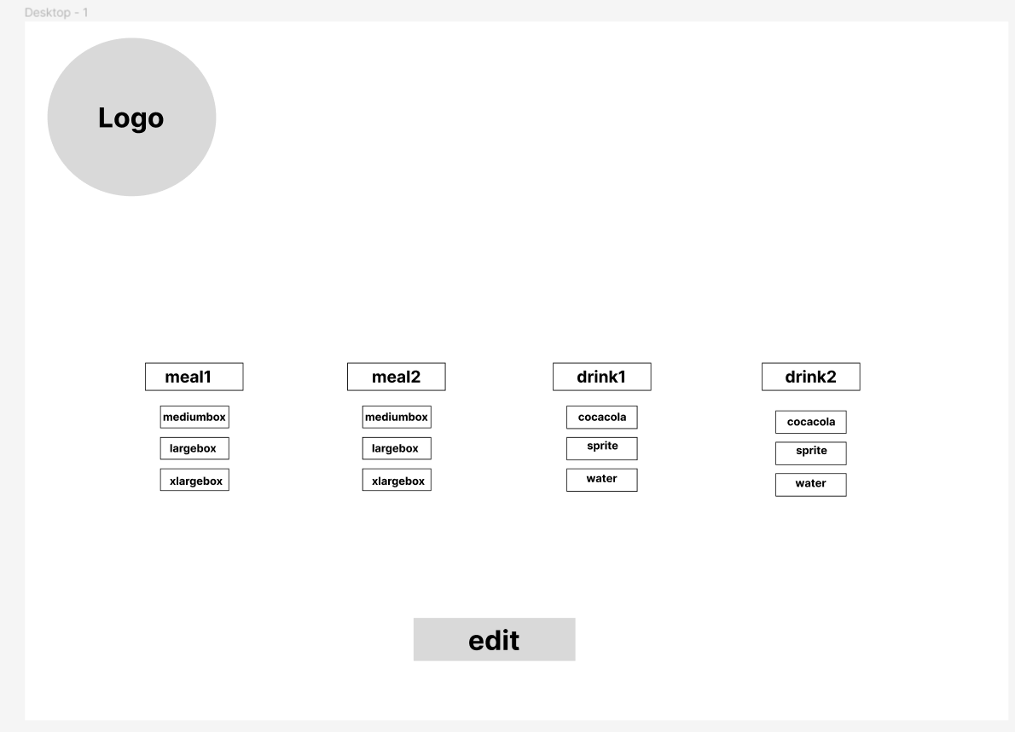

**Wireframe for both PCs and mobile view**

**Sign & login page**

|  |  |  |  |
| --- | --- | --- | --- |
| **NO.** | **Element** | **Type** | **Description** |
| 1. | Logo | Image | Website logo |
| 2. | Full name | Text field | Field to fill customer name |
| 3. | Email | Text field | Field to fill customer email |
| 4. | Address | Text field | Field to fill customer address |
| 5. | Password | Text field | Field to fill customer password |
| 6. | Forgot password | Link | Link to reset password page |
| 7. | Login | Button | Button to login and enter the website |
| 8. | Signup | Button | To register |
| 9. | Back | Button | To back for login page if the customer was in sign up page |

**Home & contact page**

|  |  |  |  |
| --- | --- | --- | --- |
| **NO.** | **Element** | **Type** | **Description** |
| 1. | Logo | Image | Website logo |
| 2. | Main menu | Nav bar | A navigation bar that contains links to main website pages |
| 3. | Order now | Button | Link to the menu page |
| 4. | Field | Image | Image that contains restaurant’s contact information |
| 5. | Restaurant map | Image | Restaurant’s map |

**Menu, cart, and edit page**

|  |  |  |  |
| --- | --- | --- | --- |
| **NO.** | **Element** | **Type** | **Description** |
| 1. | Logo | Image | Website logo |
| 2. | Main menu | Nav bar | A navigation bar that contains links to main website pages |
| 3. | Order | Image | Image of the order and its price |
| 4. | Add to cart | Button | To add item to the cart |
| 5. | Checkout | Button | To go to the cart page |
| 6. | Orders in cart | Table | Table that contain the ordered items with price |
| 7. | Delete & edit | buttons | To edit the order and go to edit page, or to delete the order |
| 8. | Logout | Button | To logout from the website |
| 9. | Change order | Button | Buttons under each item with the available options to choose for editing the order |
| 10. | Edit | Edit | Take action and edit the order and back to the cart page |

**Launching**

|  |  |
| --- | --- |
| **Domain name** | [www.hakunamatatas.com](http://www.hakunamatatas.com) |
| **Host name** | Freehosting.com |

I purchased the domain name from godaddy.com. But before this process, I chose a domain name that is close to the name of the restaurant that I want to build a website for. I then went to freehosting.com to host my website. I received two DNS URLs from freehosting.com and I went back to godaddy.com to set the DNS as the ones I received from the host. Twon I waited for like two days then the host was active. Then I went to the client area on freehosting.com and went to the direct manager to upload the files of my website and the database onto it, so by this I can search on the browser for my website.

Through the client area, I went to the direct manger and uploaded all the codes files with all images in file manager in public HTML, then through MySQL manager I created a database and then I did few changes to connection file like changing localhost and the username and password. Then I opened Php my admin in the direct manager and I put the old database, that I was testing the website on it, in the new database that I have created in the direct manager. Finally, the website was officially published, and anyone can open it through its domain name.